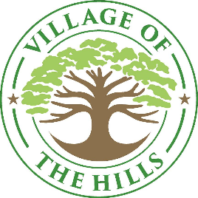
The Hills Parks and Recreation Committee
102 Trophy, The Hills, TX 78738 Monday, May 12, 2025 at 5:00 p.m.
MINUTES
- CALL TO ORDER

Chairman Weldon called the meeting to order.

- PLEDGE OF ALLEGENCE

Chairman Weldon lead the Pledge of Allegence

- PUBLIC COMMENT

Chairman Weldon gave thanks to all the commissioners who helped put up the soccer goals at The Hills Park.

- REPORTS

- City Council Liaison Update

Councilmember Khait stated that the City Council had a couple of meetings one was the Capital Workshop they discussed several capital improvements that the residents wanted, which included enclosure of the Pavilion, turf fields, mini golf, additional playground concepts and playscapes, volleyball, pickleball and tennis courts and miniature golf. It was suggested that the Parks and Recreation Commission can decide which ones they would like to proceed with and get quotes to bring to the city council.

- Business Items:

- Discuss, consider, and take any necessary action regarding Parks and Recreation Budget.

Commissioners’ discussion on budget for remaining events for the 2025 year ending.

- Discuss, consider, and take necessary action regarding upcoming Events.

Commissioners discussed:

- End of school year event Ice Cream truck to celebrate the end of the school year. Possibly June 1st or June 8th.
- Movie Night at the Park
- Ice Cream at the Club with joint venture with the Club.
- Back to school event in August.
- Tentative date for The Hills City Limits of OCT 5th.

- ADJOURN

Commissioner Rivas-Reddy made a motion to adjourn, Commissioner Mohseni seconded the motion. Meeting adjourn at 6:06 P.M.

