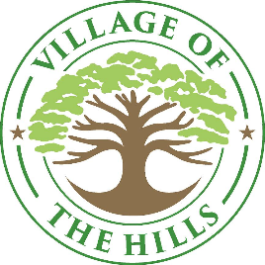

Notice of Possible Quorum

The City Council has been invited to attend the following events. Although a quorum of the members of the Council may or may not be available to attend this event, this notice is being posted to meet the requirements of the Texas Open Meetings Act and subsequent opinions of the Texas Attorney General’s Office.

The Hills Fest
Sunday, October 5, 2025, from : 1:30 P.M. to 7:00 PM
The Hills Park
2 The Hills Drive
The Hills, TX 78738

