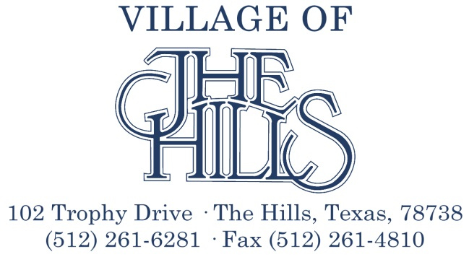

REGULAR MEETING OF THE CITY COUNCIL

MUNICIPAL OFFICES
102 TROPHY DRIVE
TUESDAY, FEBRUARY 13, 2018
9:00 AM

AGENDA

Eric B. Ovlen, Mayor J.R. Smith, Mayor Pro Tempore
Hilda Potsavich, Councilmember/Secretary Jim Nelson, Councilmember/Treasurer
Robert Smith, Councilmember George Spencer, Councilmember
Wendy L. Smith, City Manager

CALL TO ORDER

PLEDGE OF ALLEGIANCE

APPROVAL OF MINUTES

- Minutes of January 12, 2018 Special meeting

PRESENTATIONS

- Law Enforcement
- Emergency Management Coordinator
- Hills Club Liaison
- Youth Advisory Commission Liaison
- POA Liaison
- Park Liaison
- Press Liaison
- Finance Report/Treasurer’s Report
- Hurst Creek MUD
- Village Manager
- Park and Youth Advisory Commission appointments

BUSINESS ITEMS

- Consideration and possible action regarding the appointment of Officers and Liaisons
- Consideration and possible action regarding an Ordinance of the Village of The Hills Declaring Oak Wilt to be a Public Nuisance; Making it Unlawful for the Owner of Property to Maintain a Dead Live Oak or Oak Wilt Diseased Tree on the Property; and Related Matters
- Consideration and possible action on telecommunication infrastructure
- Consideration and possible action regarding the Walking Trail
- Consideration and possible action regarding the Dog Park
- Consideration and possible action regarding Park Regulations and Park Rental Agreement
- Consideration and possible action regarding painting quotes for the perimeter fence

ANNOUNCEMENTS AND REQUESTS

- New business items to be included on the next agenda

PUBLIC COMMENT FROM ATTENDING VISITORS AND GUEST

EXECUTIVE SESSION

The Mayor and Board of Aldermen may adjourn into Executive Session at any time during the course of this meeting to discuss any matters listed on the agenda, as authorized by the Texas Government Code including, but not limited to, Sections §441.071 (Consultation with attorney), §551.072 (Deliberations about Real Property), §551.073 (Deliberations about Gifts and Donations), §551.074 (Personnel Matters), §551.076 (Deliberations about Security Devices),§551.087 (Economic Development), §418.183 (Deliberations about Homeland Security Issues), and as authorized by the Texas Tax Code including, but not limited to Section 321.3022 (Sales Tax Information).

RECONVENE INTO OPEN SESSION AND TAKE ANY NECESSARY ACTION RELATING TO THE EXECUTIVE SESSION AS DESCRIBED ABOVE.

ADJOURNMENT
______________________________________
Eric B. Ovlen, Mayor

ACTION MAY BE TAKEN BY THE BOARD OF ALDERMEN ON ANY LAWFUL SUBJECT LISTED ON THIS AGENDA.
CERTIFICATION
I hereby certify the above Notice of Meeting was posted on the bulletin board at the Village of The Hills offices on February 8, 2018, at
_______________________________________
Linda Lunney, City Secretary

NOTE: In compliance with the Americans with Disabilities Act, The Village of The Hills will provide for reasonable accommodations for persons attending public meetings. To better serve attendees, requests should be received 24 hours prior to the meeting. Please contact the City Secretary’s Office at 512-261-6281.

